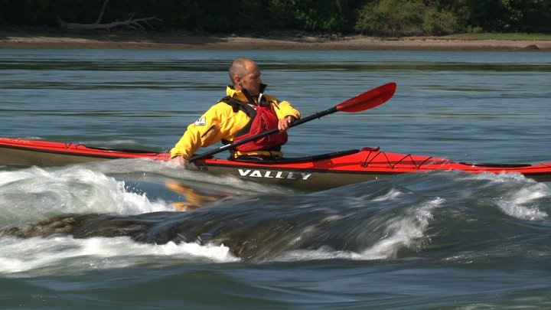

Nick Cunliffe
We are very fortunate to have Nick Cunliffe visiting Tasmania in 2015.
Nick is a BCU Level 5 Coach in Sea and White Water. He is based in North Wales and will be providing instruction to the Tasmanian Sea Canoe Club and Canoe Tasmania members in February and March 2015.

Nick runs a business in Wales called Kayak Essentials http://www.kayakessentials.co.uk/
which offers high level BCU coaching, other sea kayak courses and instructional DVDs.
He has paddled and led expeditions in many parts of the world and is in great demand as a high level coach at symposiums and events worldwide.

It should be noted that non-advanced sessions will be suitable for beginner to intermediate
Paddlers, and advanced sessions will be suitable for intermediate paddlers that want to
extend themselves as well as experienced paddlers.

All courses will be at venues in the south of the State, with actual location determined by conditions at the time.

Cost will be $65 per person per half day session.

Dates and courses offered:

14th February
am Rough Water Handling
pm Incident Management (includes towing and rescues)
15th February
am Advanced Rough Water Handling
pm Advanced Incident management
21st February
am Surf
pm Rough Water Handling
22nd February
am Surf
pm Boat Handling
28th February
am Advanced Rough Water Handling
pm Advanced Incident Management
1st March
am Paddling on Moving Water in a Sea Kayak
pm Forward Paddling

For more information, please contact Geoff Murray at: geoff@geoffmurray.com

